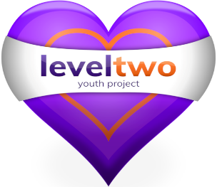
FELIXSTOWE YOUTH DEVELOPMENT GROUP LEVEL TWO YOUTH PROJECT DEVELOPMENT PLAN 2023/24

INTRODUCTION

Who we are:-
We are a Registered Charity & a Company Limited by Guarantee. Established in 2001, we are the only providers of comprehensive youth services for young people in Felixstowe & the surrounding area.

Our vision is to increase the life skills and advance the non-formal education of children and young people aged 7-25 years; and to meet the health and well-being needs of children, young people and families in Felixstowe and the surrounding area.

We will do this by:- meeting the needs of vulnerable children and young people who are referred to us;
providing information, advice and guidance through our Early Intervention programme;
offering mentoring and counselling services;
working in schools;
offering our Outreach service to young people not easily able to access centre based provision;
working with families when our work with a young person makes this appropriate.

We commit to the following values in our relationships with each other, with young people and their families, and with our partner organisations.
Integrity: be honest, transparent, trustworthy and true to our beliefs;
Passion: be positive and enthusiastic about what we are trying to achieve;
Aspiration: aim for our best and set high, realistic goals;
Resilience: never give up and strive to improve;
Accountability: take responsibility for our words, thoughts and actions.
Respect: for ourselves, our environment and other people.

Leadership and Management structure
We commit to abiding by up to date and legally compliant Articles of Association
As a limited company we will maintain a list of Members.
Governance will be the responsibility of a Board of Trustees/Directors
The Project Manager (CEO) will lead a Senior Team (currently including Deputy Project Manager, Principal Youth Worker and Counselling Lead Professional). They will ensure the delivery of provision, the achievement of outcomes by young people & the ability of the Project to be flexible & responsive to need.

Finance
We believe it is vital that our provision is offered free to children, young people and families as the more vulnerable they are the less likely they will be able and willing to afford to pay. The exception is that we may ask for a contribution to holiday trips. We are mostly a Grant funded organisation, with a track record of success in attracting funding & providing value for money.
We will make it a priority to apply to a range of funders, local and national, and to maintain positive relationships with them by keeping them informed and providing monitoring reports as required.

